**Exam – 02**

**50 points**

**I. Instructions to create the project.**

1. You will be creating Nations Bird App for this exam. We will be entering a country name and finding display the respective bird image in the next screen.
2. Create a project in XCode with the name “**LastName_Exam02**”.
3. While creating the app make sure to follow minimum deployment and project format as shown below:

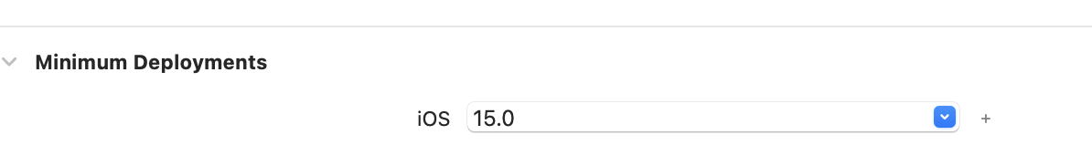

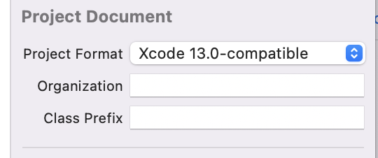

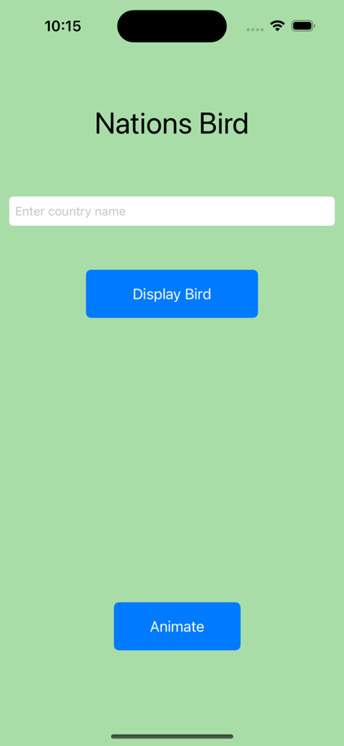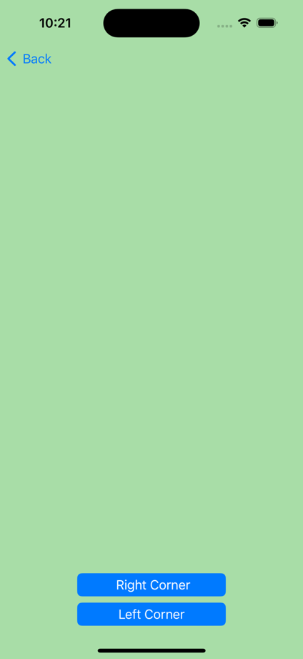

**Figure 1: App Design Screen – 1 Figure 2: App Design Screen – 2**

**II. Instructions to create the Nation’s Bird App.**

1. Design and implement the **Find the Nation’s Bird App**. For this app, we provided the images of the birds. You are allowed to use the names of view controllers and segues of your choice. Let us consider the following nations.(Hint: Use arrays to store the Nations name and Birds name.)

|  |  |
| --- | --- |
| **Nation** | **Bird** |
| Australia | Emu |
| United States | Bald Eagle |
| Canada | Canada Jay |
| New Zealand | Kiwi |
| South Korea | Korean Magpie |

1. Your app should consist of the following UI components and you may use your own colors of choice.

a. View – 1 (Figure 1)

* + 1. A header label shows ‘**Nations Bird**’ in your choice of color
    2. One text field to enter ***Nation’s name***
    3. **Display bird** button– finds and display the country’s national bird
    4. An image view to display the country’s national bird after clicking the **display bird** button. You can set the size of the image view as 300x300 in the size inspector window.
    5. **Animate** button**–** When user clicks the animate button, the system willnavigate to the View 2 as shown in Figure 2.
  1. View – 2 (Figure 2)
     1. An image view to display the image after clicking animate button in step 2.a.v
     2. A button named **Top left corner**
     3. A button named **Bottom right corner**

**III. Refer below images for sample output**

Check the **app recording** provided in the exam2 folder for animation output.

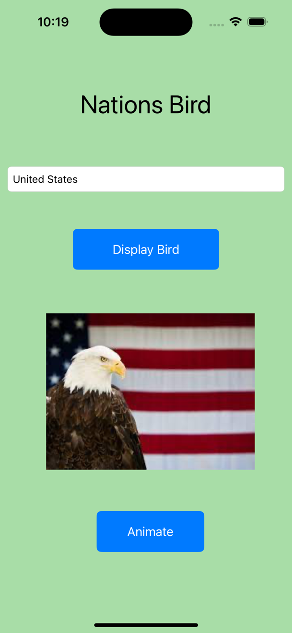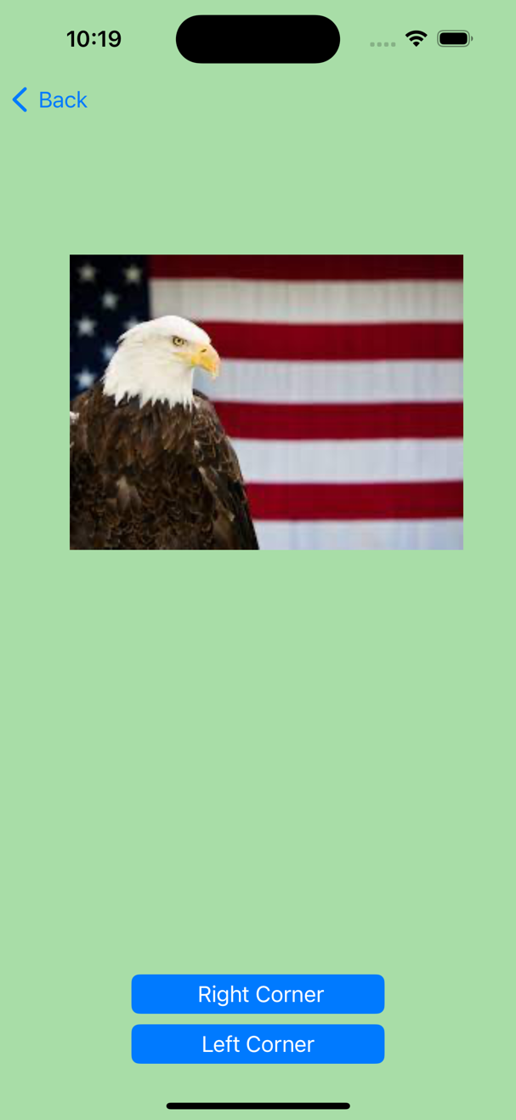

**Figure 3: View of Screen - 1** **Figure 4: View of Screen - 2**

**IV. Submission Instructions:**

1. Save your XCode project of Nations Bird App

2. Name it with your LastName_Exam02. Compress the folder and submit it to this exam.